Final requirements

In order to better manage human resources and communicate work goals more conveniently, we decided to develop ROSTER Management system. Applying knowledge management technology to utilize its human resources and strengthen its personnel management can make more effective use of knowledge assets and resources.(Soliman, & Spooner,2000)The main function is to manage the working hours of the casual staffs hired by the company. The employees first log in to the system to provide the available working hours, and the managers will then assign the matching work items. Finally, the work results of the staff can be evaluated through the recorded working hours and work results. .

The system will be completed in the form of a web page containing a database containing login and registration and dashboard pages used by administrators. At the beginning, the staff registered an account, and filled in the name, email, phone number and position to complete the creation of the account. After logging in to the account, there will be a form to fill in the daily working hours within a week, the current work goals will be displayed at the bottom, and the relevant resource files or audio and video files will be displayed for personnel training. This page can also record work proposals and upload related verification documents.

After logging in, the staff can click on the working hours to clock in and record the working hours.

Managers can enter the dashboard page, first enter the account password to enter the personnel management system, this page displays the personnel list, there is a list of all personnel or can choose to list only the personnel associated with a single work item, click personnel to see their daily availability. During the working period, you can choose whether it is a working status by changing the status. You can select the work item of the staff in the field of the target work item. Click the staff work statistics to display the working hours of the staff each week. Finally, you can count the working hours of the staff every week and figure out salary.

Under the dashboard page, managers can create a work item, enter its start and end time, minimum and maximum personnel requirements, upload related files and resource files or audio and video files, and record related work instructions

There is a statistics page under the dashboard page to display the start and end time of each work item. Managers can select the relevant personnel of the work item to leave comments on them and choose A~E, which can be used as a reference for rewards. Evaluation can improve the overall performance of a company, and adding an evaluation system is a simple and effective way to do it.(Islam, & bin,2006)When selecting a staff, each staff member's work item, working hours used and last completed evaluation are displayed for each staff member.

The staff login password can be modified on the login page, the original password must be entered twice, and then the new password must be entered. When you enter the wrong password three times on the login page, you must wait for 30 minutes. If you forget your password, you can enter your email to get the password again.

The response time of the web page of ROSTER Management system is no more than two seconds at any time, and the time for the web page to complete the database reading and loading is no more than five seconds.

It is important to add disaster recovery plans and business continuity plans so backup systems must be used.(Alnahari, 2021)Under the dashboard page, you can use USB to back up all web pages and database files to avoid data loss caused by human or equipment damage.

The operating device that is usually run is a computer, but the webpage must comply with the html specification. It can be operated normally using windows and mac, but basic operations such as login can be completed by using devices such as mobile phones or tablets.

Sitemap

nces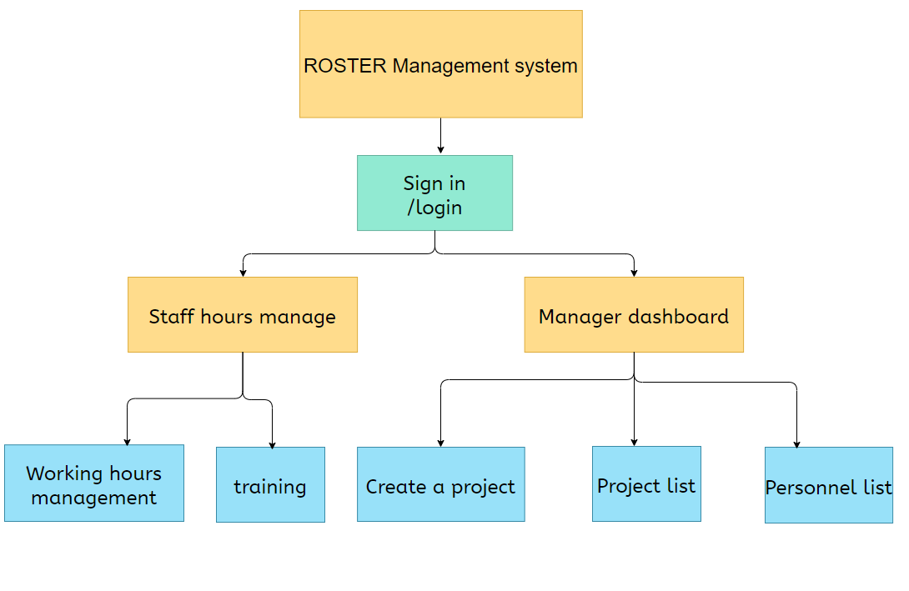

References

Soliman, F., & Spooner, K. (2000). Strategies for implementing knowledge management: role of human resources management. *Journal of knowledge management*.

Alnahari, W. (2021). Information Security Protection and Planning for: Continuity and Security.

Islam, R., & bin Mohd Rasad, S. (2006). Employee performance evaluation by the AHP: A case study. *Asia Pacific Management Review*, *11*(3).